Warning – Emergency Door Ajar for Legacy C1MCA HMI with “i” Telltale – CGEA1.3

Functional Description

The Emergency Door Ajar Warning illuminates the “i” telltale, provides a warning text message, and a continuous chime to inform the driver that the vehicle emergency door is ajar. This warning and chime is generally used only on commercial vehicles. The continuous chime associated with this warning is required for all ECE markets per ECE Reg52-01: Construction of Small Capacity Regulation section 5.6.7.5.. To provide the continuous audible warning the Headlamp On Warning Chime is employed as the Headlamp On warning is never sounded when the ignition is On. Uses are mutually exclusive.

This STSS is to be used only for CGEA 1.3 applications which use Legacy C1MCA HMI with “i” Telltale. Currently the only program this STSS is to be used on is 2016.5 V363 which is CGEA1.3. Long term this function is to
be incorporated into the Door, Liftgate, Liftgate/Liftglass Ajar RTT; Trunk Ajar RTT; Hood Ajar RTT; and Messages
STSS and the Door, Liftgate, Liftglass Ajar Telltale STSS.

The Emergency Door Ajar warning correlates the DrStatInnrTgate_B_Actl signal, DrStatTgate_B_Actl signal, PwPckTq_D_Stat signal, and the Operational mode to determine when to display the warning, illuminate the “i”Telltale, and sound the continuous chime (Headlamp On Chime is used for this application).

Interfaces

Interface Context Diagram (I/O Block Diagram)

Figure 1 Warning – Emergency Door Ajar Context Diagram
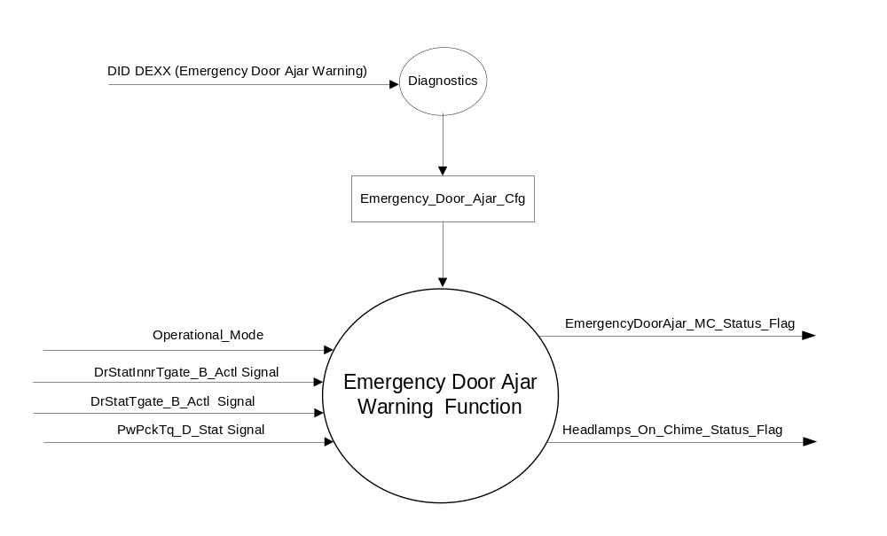

Inputs
      - INTERNAL:
    - Operational_Mode
    - Emergency_Door_Ajar_Cfg

- MUX signal on the CAN bus

- DrStatInnrTgate_B_Actl Signal
Signal Name | Size (bits) | Detail | Units | Res. | Offset | State Encoded | Min | Max
DrStatInnrTgate_B_Actl | 1 |  | SED | 1 | 0 |  | 0 (0x0) | 1 (0x1)
 |  | Closed |  |  |  | 0x0
 |  | Ajar |  |  |  | 0x1

- DrStatTgate_B_Actl Signal
Signal Name | Size (bits) | Detail | Units | Res. | Offset | State Encoded | Min | Max
DrStatTgate_B_Actl | 1 |  | SED | 1 | 0 |  | 0 (0x0) | 1 (0x1)
 |  | Closed |  |  |  | 0x0
 |  | Ajar |  |  |  | 0x1

- PwPckTq_D_Stat Signal
Signal Name | Size (bits) | Detail | Units | Res. | Offset | State  Encoded | Min | Max
PwPckTq_D_Stat Signal | 2 |  | SED | 1 | 0 |  | 0 (0x0) | 3 (0x3)
 |  | PwPckOff_TqNotAvailable |  |  |  | 0x0
 |  | PwPckOn_TqNotAvailable |  |  |  | 0x1
 |  | StartInPrgrss_TqNotAvail |  |  |  | 0x2
 |  | PwPckOn_TqAvailable |  |  |  | 0x3

Outputs
EmergencyDoorAjar_MC_Status_Flag, used to control the Warning displayed in the message center.
Headlamps_On_Chime_Status_Flag, used to control the continuous audible warning.

Function/Performance

Operational Modes

Mode | Differentiating Vehicle Conditions
Sleep Mode | Emergency Door Ajar Warning Inactive
Limited Mode | Emergency Door Ajar Warning Inactive
Normal Mode | Emergency Door Ajar Warning Active/Inactive
Crank Mode | Emergency Door Ajar Warning Inactive
The above table references the setting of the Warning flags as per this section. However, the actual warning display operational modes are defined in the Message Center section of this SPSS.

Mode | Differentiating Vehicle Conditions
Sleep Mode | Headlamp On Chime OFF
Limited Mode | Headlamp On Chime OFF
Normal Mode | Headlamp On Chime OFF / ON
Crank Mode | OFF
Note: Above includes function due to this feature only. See Headlamps On Chime section for additional operating mode function.

Voltage Levels

Refer to the Cluster Features Table located in the Operational Modes and Voltage Range Strategies Section of this SPSS

Human-Machine Interface

Visual

1.3.3.1.1 Indicator Graphics / Display Format
Message Center Text Warning Messages as defined in section 1.3.5.1 of this document.

1.3.3.1.2 Indicator Color Coordinates

Reference section COLOR & ILLUMINATION REQUIREMENTS (GRAPHICS).

Audio

See Table 1.4.

Switch Control Logic

None.

System Accuracy

Within 100 msec of receiving a message that results in a change of state the cluster will update the output flag to the proper state.

Operation: Performance and Functional

Subsystem Algorithm Flowchart / State Diagram
Figure 2: Emergency Door Ajar Diagnostic Configuration Flowchart
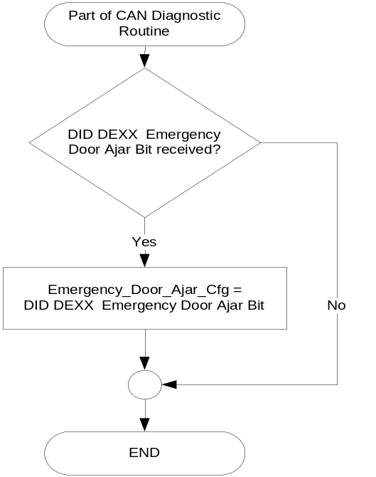

- State Matrix for Emergency Door Ajar Warning and Chime
Emergency_Door  _Ajar_Cfg | Operational_Mode | PwPckTq_D_Stat Signal | DrStatInnrTgate_B_Actl  Signal | DrStatTgate_B_Actl  Signal | EmergencyDoorAjar  _MC_Status_Flag
Enabled (0x1) | Normal | PwPckOn_TqAvailable (0x3) | Ajar (0x1) | X | Active
Enabled (0x1) | Normal | PwPckOn_TqAvailable (0x3) | X | Ajar (0x1) | Active
All Other Cases |  |  |  |  | Inactive

- MC Status Flag to MC Warning Message ID
EmergencyDoorAjar  _MC_Status_Flag | MC Warning ID | Active Chime_Status_Flag
Active | W116 | Headlamps_On_Chime_Status_Flag
Headlamps_On_Chime_Status_Flag also set to Active as per Headlamps On Chime section of this SPSS.

Operation Description (supports algorithm flowchart /state diagram)

- For definition of how the Message Center arbitrates and displays Active warnings, see the Warning / Alert Display Logic Diagram, located in the Message Center – X Display with Y Button Interface section of this SPSS (where X and Y are appropriate values in this document).
- When EmergencyDoorAjar_MC_Status_Flag = Active then the “i” telltale shall be illuminated.

Function Safety Classification (EMC)

Class B

Memory Storage
Parameter Name | Description | Value at  Battery Connect | Value at  Module Wake-up
Emergency_Door_Ajar_Cfg | State Indicator for feature presence controlled via CAN at EOL at VO plant. Defaulted to DISABLED at supplier manufacturing. | Use Stored Value | Use Stored Value
DrStatInnrTgate_B_Actl | CAN Signal sent from BCM | Closed (0x0) | Closed (0x0)
DrStatTgate_B_Actl | CAN Signal sent from BCM | Closed (0x0) | Closed (0x0)
PwPckTq_D_Stat Signal | CAN Signal sent from PCM | PwPckOff  _TqNotAvailable  (0x0) | PwPckOff  _TqNotAvailable  (0x0)
EmergencyDoorAjar_MC_Status_Flag | State variable used by M/C Warning Arbitrator | Inactive | Inactive
Headlamps_On_Chime_Status_Flag | State variable used by the Chime Arbitrator | Inactive | Do Not Init
Operational_Mode | 4 state indicator for cluster operational mode | Limited | Limited or Normal or Crank

Prove Out

No.

Reconfigurable Telltale

No.

Message Center Msg

See Table 1.4

Error Handling

Missing Message Strategy

The signals will be declared missing as per the Diagnostics section of this SPSS.

DTCs states and history will be determined as per the Diagnostics section of this SPSS.

Diagnostics

Self Test

None

Engineering Test Mode

Not Applicable

Part II Performance

DID DEXX
Block  Num | Block Description | Size (bits) | Type | Byte(s) | Bits | State: Description | "0" | "1" | Default | Comments/  Information
PACKETED BLOCKS
$XX | Option Content (B&A) | * | 1 | * | 1 | Emergency Door Ajar Warning | Disabled | Enabled | Disabled
*Byte and bit location to be identified in Part II Specification for this cluster

Supported Diagnostic Trouble Codes (DTCs)
DTC | Description
C14000 | Lost Communication With Body Control Module Missing Message
C10000 | Lost communication with ECM/PCM

Reference Specification

IS-0001 WARNINGS/INDICATORS/DISPLAYS PROVEOUT
IS-0052 OPERATING VOLTAGES - FUNCTIONAL/PERFORMANCE
IS-0069 FUNCTIONAL IMPORTANCE CLASS
IS-0324 WINDSHIELD & OTHER REFLECTIONS
IS-0327 WARNING INDICATOR EVALUATION
IS-0379 NORTH AMERICAN WARNINGS AND INDICATORS STRATEGY

IL-0017 TELLTALE AND INTERIOR ILLUMINATION – COLOR AND INTENSITY
IL-0019 GENERAL ILLUMINATION DIMMING
IL-0021 CRAFTSMANSHIP – DISPLAYS
IL-0022 GENERAL ILLUMINTATION COLOR
IL-0023 CLARITY/LEGIBILITY/READABILITY/VISUAL CONTRAST
IL -0043 OPERATIONAL ENVIRONMENT FUNCTIONALITY
IL -0045 COLOR
IL -0047 TELLTALE, INDICATOR AND DISPLAY LIGHT INTENSITY
IL -0048 ILLUMINATION ACCEPTABILITY

03-0661 PLACEMENT: CONTROL AND DISPLAY LOCATIONS
03-0662 PLACEMENT: LOGICAL GROUPING FUNCTION AND USAGE
03-0664 PLACEMENT: DOWN VISION TO COMPONENTS WITH HIGH VISUAL DEMAND
03-0665 PLACEMENT: EXPECTED LOCATIONS OF CONTROLS AND DISPLAYS VDS
03-0670 INTERIOR VISIBILITY
03-0671 INTERIOR VISIBILITY: REFLECTIONS FROM COMPONENTS & SURFACES
03-0672 INTERIOR VISIBILITY: REFLECTIONS IN DISPLAYS
03-0673 INTERIOR VISIBILITY: VISUAL OBSCURATIONS
03-0674 INTERIOR VISIBILITY: ILLUMINATION CONTROLS / DISPLAYS
03-0675 INTERIOR VISIBILITY: VEILING GLARE
03-0677 INTERIOR VISIBILITY: SUNLIGHT WASHOUT
03-0681 IDENTIFICATION: CHARACTER AND SYMBOL SIZE
03-0682 IDENTIFICATION: LEGIBILITY
03-0685 IDENTIFICATION: SYMBOLS, ABBREV FOR CONTROL
03-0721 LOGIC OF OPERATION: OPERATIONAL STEREOTYPES
03-0722 LOGIC OF OPERATION: INTERPRETATION
03-0723 LOGIC OF OPERATION: USE OF SYSTEMS WITH VISUAL DISPLAYS

Revision History

SPSS Module Revision History

Revision  Level | Name | Change Description | Date
1.0 | J. Blatchford | Initial release. | 10/21/14

